1. How to compare two JSON have the same properties without order?
   1. var obj1 = { name: "Person 1", age:5 };
   2. var obj2 = { age:5, name: "Person 1" };

**CODE:**

var obj1 = { name: "Person 1", age:5 };

var obj2 = { age:5, name: "Person 1" };

var flag=true;//set flag is true default

if(obj1.length!==obj2.length)// if both object length are not same set flag is false

 flag=false;

else

 for(let i in obj1)//for loop return key and value of object1

 {

    if(obj1[i]!==obj2[i])//if key or value not same in both object

    {

       flag=false;//set flag is false

    }

 }

if(flag==true)//true means Equal and false means Not Equal

   console.log('Equal');

else

   console.log('Not Equal');

**OUTPUT:**

Equal

1. Use the rest countries API url -><https://restcountries.eu/rest/v2/all> and display all the country flags in console

html file name:**task1.html**

<!DOCTYPE html>

<html lang="en">

<head>

    <meta charset="UTF-8">

    <meta http-equiv="X-UA-Compatible" content="IE=edge">

    <meta name="viewport" content="width=device-width, initial-scale=1.0">

    <title>Document</title>

</head>

<body>

    <script src='task1.js'></script>

</body>

</html>

js file Name:**task1.js**

var request=new XMLHttpRequest();

request.open('GET','https://restcountries.com/v2/all',true);

request.send();

request.onload=function(){

    var data=JSON.parse(request.response);

    console.log(data);

    for(let i=0;i<data.length;i++)

    {

        console.log(data[i].flag);

    }

};

**output:**

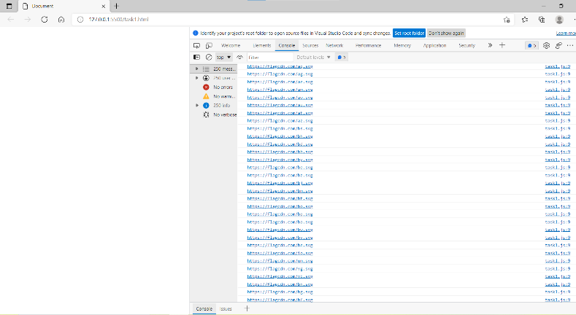

1. Use the same rest countries and print all countries name, region, sub region and population

**task1.js**

var request=new XMLHttpRequest();

request.open('GET','https://restcountries.com/v2/all',true);

request.send();

request.onload=function(){

    var data=JSON.parse(request.response);

    console.log(data);

    for(let i=0;i<data.length;i++)

    {

       // console.log(data[i].flag);

     console.log(data[i].name,data[i].region,data[i].subregion,data[i].population);

    }

};

**Output:**

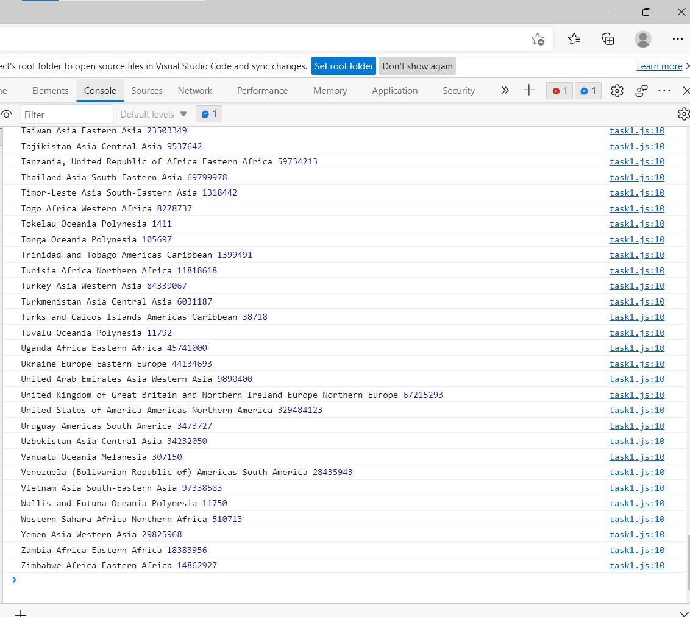

1. <https://medium.com/@reach2arunprakash/www-guvi-io-zen-d395deec1373>

**Task1:**

1. Declare four variables without assigning values and print them in console

var a;

var b;

var c;

var d;

console.log(a,b,c,d);

**output**:  
 undefined undefined undefined undefined

2.How to get value of the variable myvar as output

var myvar= 1;  
console.log("myvar");

**correction:**

console.log(myvar);

3.Declare variables to store your first name, last name, marital status, country and age in multiple lines

let firstname="Madhumidha";

let lastname="Boopalan";

let martialstatus=true;

let country="India”;

let age=31;

4.Declare variables to store your first name, last name, marital status, country and age in a single line

let firstname="Madhumidha",lastname="Boopalan",martialstatus=true,country="India",age=31;

console.log(firstname,lastname,martialstatus,country,age)

5. Declare variables and assign string, boolean, undefined and null data types

let a=" ";

a=true;

a=undefined;

a=null;

6.Convert the string to integer

let str=’2’;

str=parseInt(str);

str=Number(str);

str=+str;

7. Write 6 statement which provide truthy & falsey values.

|  |  |
| --- | --- |
| console.log(val?true:false); | |
| Truely | Falsey |
| let val=’2’;  val=true;  val=7;  val={};  val=[];  val=[1,2,3]; | let val=’’;  val=false;  val=undefined;  val=null;  val=NaN;  val=-0; |

**Task2**

**8.Square of Number**

let num=9;

let res=Math.sqrt(num);

console.log(res);//3

**9.Swapping Of 2 Numbers**

let a=8;

let b=9;

let temp;

temp=a;

a=b;

b=a;

console.log(a,b);//9 8

**10.Addition of 3 Numbers**

let a=b=c=9;

console.log(a+b+c);//27

**11. Celsius to Fahrenheit**

let c=20;

let F=C*(9/5)+32;

console.log(F);//68

**12.Meter to miles**

let meter=15;

let miles=meter* 0.0006213712 ;

console.log(miles);// 0.0093205679

**13.Pounds to kg**

let pound=4;

let kg=pound* 0.45359237;

console.log(kg);// 1.81436948

Task3

#  
##  
###  
####  
#####  
######  
#######

14.Code for print above output

let ip="";

for(let i=0;i<7;i++)

{

ip+='#'

console.log(ip);

}